

SIMATS ENGINEERING
Saveetha Institute of Medical and Technical Sciences Chennai- 602105

Student Name: V. Shalini Reg. No.: 192525373
Course Code: CSA0509 Slot: A
Course Name: Database Management Systems
Course Faculty: Dr. Kesavan R

Project Title: Smart Water Utility Consumption, Billing, and Complaint Management System
Module Photographs: 3 photographs –Module Photo, Individual student contribution module work in the project and presentation image
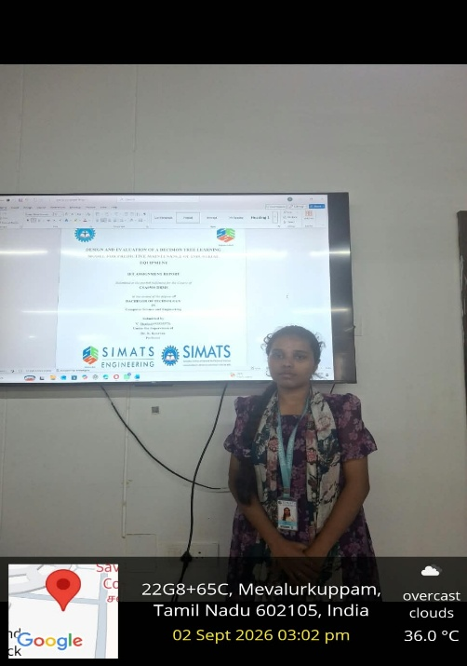
Project Description: I worked on database design, SQL queries, billing, payments, and complaint management.
I contributed to the development of the Smart Water Utility Consumption, Billing, and Complaint Management System by assisting with database creation, data organization, and query implementation. I worked on designing and maintaining tables related to customers, water connections, meter readings, bills, payments, and complaints. I also helped define suitable primary keys, foreign keys, and relationships between the different entities to maintain data consistency.
As part of my contribution, I developed and tested SQL queries for inserting, updating, deleting, and retrieving water utility information. I worked on retrieving customer consumption details, generating billing information based on meter readings, checking payment records, and monitoring complaint status. I also assisted in identifying and correcting database errors during testing.

Student Signature Guide Signature

